Special Operators : BETWEEN, IN, NOT IN , LIKE

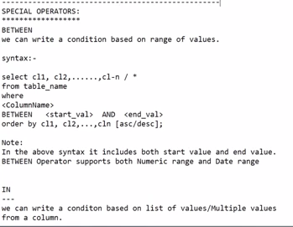

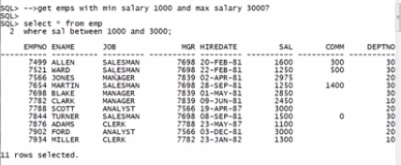

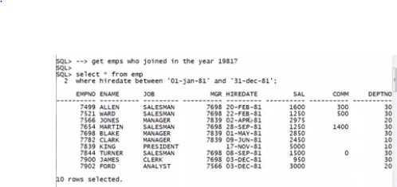

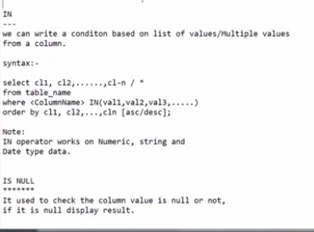

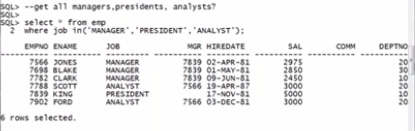

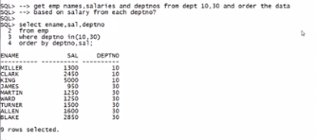

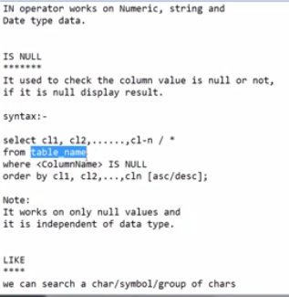

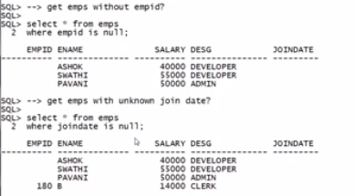

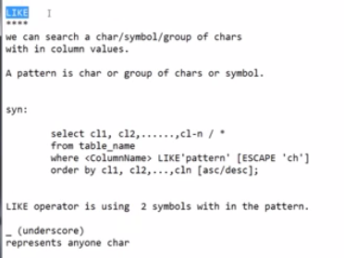

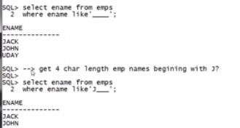

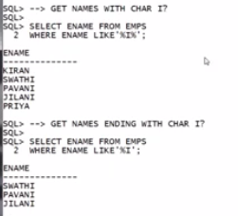

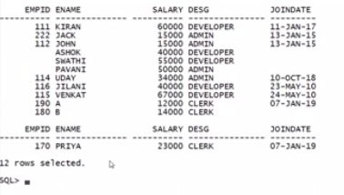

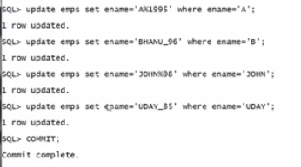

WE CAN USE BACK SLASH TO CANCEL THE _ AND % SYMBOLS IN SELECT COMMAND IF WE HAVE ANY OF THESE SYMBOLS EXISTS IN TABLE.

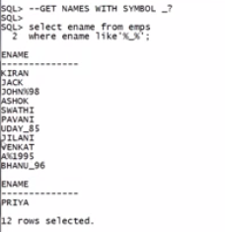

SQL> SELECT * FROM EMP WHERE ENAME LIKE 'SUR\_%' ESCAPE'\';

EMPNO ENAME JOB MGR HIREDATE SAL COMM

---------- ---------- --------- ---------- --------- ---------- ----------

DEPTNO

----------

111 SUR_ESH

